**Topics: Descriptive Statistics and Probability**

1. Look at the data given below. Plot the data, find the outliers and find out $μ, σ, σ^{2}$

|  |  |
| --- | --- |
| **Name of company** | **Measure X** |
| Allied Signal | 24.23% |
| Bankers Trust | 25.53% |
| General Mills | 25.41% |
| ITT Industries | 24.14% |
| J.P.Morgan & Co. | 29.62% |
| Lehman Brothers | 28.25% |
| Marriott | 25.81% |
| MCI | 24.39% |
| Merrill Lynch | 40.26% |
| Microsoft | 32.95% |
| Morgan Stanley | 91.36% |
| Sun Microsystems | 25.99% |
| Travelers | 39.42% |
| US Airways | 26.71% |
| Warner-Lambert | 35.00% |

***Answers:***

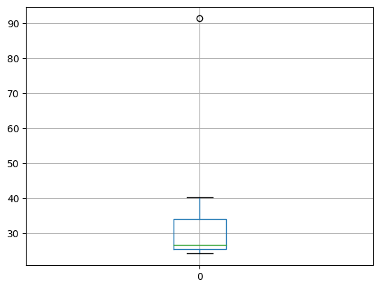

***Mean***: 33.271333

***Variance***: 287.146612

***Standard Deviation***: 16.945401



Answer the following three questions based on the box-plot above.

1. What is inter-quartile range of this dataset? (please approximate the numbers) In one line, explain what this value implies.

Answer: Inter Quartile Range=Upper quartile – Lower Quartile

**IQR=12-5=7**

50% Data lies between **IQR**

1. What can we say about the skewness of this dataset?

Answer=The Above boxplot has **positive skewness**

1. If it was found that the data point with the value 25 is actually 2.5, how would the new box-plot be affected.

Answer=If the values of 25 is changed to 2.5 ,there is no outliers found in the boxplot ,is the value is changed to 2.5 again we need calculate mean and median.



Answer the following three questions based on the histogram above.

1. Where would the mode of this dataset lie?

**Answer:** The mode found in the range of the points 3 and 10.

1. Comment on the skewness of the dataset.

**Answer**: The Above Histogram has **Positive Skewness**

1. Suppose that the above histogram and the box-plot in question 2 are plotted for the same dataset. Explain how these graphs complement each other in providing information about any dataset.

**Answer**: If both Histogram and Boxplot plotted for same dataset then we can observe that the data set is **having one Outlier at the point 25.** Both plots are having **Positive Skewness.**

1. AT&T was running commercials in 1990 aimed at luring back customers who had switched to one of the other long-distance phone service providers. One such commercial shows a businessman trying to reach Phoenix and mistakenly getting Fiji, where a half-naked native on a beach responds incomprehensibly in Polynesian. When asked about this advertisement, AT&T admitted that the portrayed incident did not actually take place but added that this was an enactment of something that “could happen.” Suppose that one in 200 long-distance telephone calls is misdirected. What is the probability that at least one in five attempted telephone calls reaches the wrong number? (Assume independence of attempts.)

***Answer:***

Lets Assume X as a Probability of one call misdirected out of 200

X= Probability of 1 call misdirected out of 200

P(X)=1/200

So probability of having at least one successful call

1-P(X)=1-1/200

199/200=0.967

As Every event is independent of other event the probability will be

1-(0.967)^5

**0.02475= 2% chance**

1. Returns on a certain business venture, to the nearest $1,000, are known to follow the following probability distribution

|  |  |
| --- | --- |
| x | P(x) |
| -2,000 | 0.1 |
| -1,000 | 0.1 |
| 0 | 0.2 |
| 1000 | 0.2 |
| 2000 | 0.3 |
| 3000 | 0.1 |

1. What is the most likely monetary outcome of the business venture?

Answer:2000 is the most likely monetary outcome of the business venture because it has the highest probability.

1. Is the venture likely to be successful? Explain

Answer: Yes because the probability of failure is less as compared to probability of success ,every business need high probability of success and less of Failure .

1. What is the long-term average earning of business ventures of this kind? Explain

Answer: The Long term average earning of business venture is:

**(-2000*0.1)+(-1000*0.1)+(0*0.2)+(1000*0.2)+(2000*0.3)+(3000*0.1)=800**

**Therefore The Long term average earning of business venture is:800**

1. What is the good measure of the risk involved in a venture of this kind? Compute this measure.

Answer: a good measure to evaluate risk involved in a venture would be variance and standard deviation of the variable x

Variance =3500000

Standard deviation=1870.82

The large value of standard deviation of **$1870** is considered along with the average returns of $800 indicates that this venture is highly risky